Introduction to Psychology (PSYC-SHU 101)
Experimental Discovery 2
NYU Shanghai
Group number: 3
Complete names of all group members: Alok Rao, Elena Ruckle, Arai Temirgalina, Jiaying Liu, Khongorzul Batbayar, Yichen Sun
Research question: Does being unfairly treated by a friend or by a stranger trigger more anger?
ED Instructor: Junho Lee
Date: XX, XX, 2025
Instructor comments:
Introduction
The way individuals assess anger and morality is subjective, and can depend on a variety of factors. In this study, we analyse how interpersonal relationships impact individuals’ assessment of morality and their level of anger in response to being treated unfairly in a hypothetical scenario. Andrea J. Phelps, Lisa Dell, and Kim Murray address the concept of Moral Injury in a book titled “Anger at Work: Prevention, Intervention, and Treatment in High-Risk Occupations”. Moral injury is a term which can be described as a lasting impact resulting from perpetrating, experiencing, or witnessing acts that defy deeply held moral beliefs and expectations (insert citation?). Potentially morally injurious events have a higher likelihood of causing harm in high-risk situations, whereas the scenario we present is a low-risk situation that is still enough to elicit feelings of anger and moral frustration. By focusing on the impact of one particular variable, that being the individual’s relationship with the perpetrator of an immoral act, we may better predict the possibility of a morally injurious event.
Instructor comment: Write a concise introduction (about 150 words) where you explain the background and importance of this topic (stay objective and scientific, do not state personal opinions). No references are required for this assignment, but if you wish to include any, you may (e.g., sources for materials or any background article you may have found).
Research question and hypotheses

Research question:
Does being unfairly treated by a friend or by a stranger trigger more anger?
Hypotheses:
We expected that being unfairly treated by friends will trigger more anger than being unfairly treated by strangers.
Instructor comment: Clearly and concisely formulate the research question and define your hypotheses. The hypotheses (null hypothesis and experimental hypothesis) should be specific and include specific expected outcomes for each level of the independent variable (e.g., we expected that female ratings would be higher than male ratings…).

Method
Participants
Instructor comment: The total number, the number per group, and whatever other information you have (e.g., the gender, country, mean age per group). If you have no information, then present a general description of the sample - how many per group, how/ where you recruited participants to collect the data. You should also explain if you excluded any data – be specific.
The FRIEND scenario: 20 respondents from the PSYC course.
The STRANGER scenario: 25 respondents from the PSYC course.
Excluded data：Those who answered the concentration question incorrectly.(Those who didn’t answer Jason to the name question.)
Materials
The platform Qualtrics was used to create the survey for this study. In the survey, the participants were presented with a randomly assigned text that describes a scenario that takes place in the workplace. Two scenarios were written with a slight difference for the independent variable, that being the relationship between the participant and their hypothetical work partner, Jason. In one text, Jason is a stranger; while in the other, Jason is a friend.
Instructor comment: Give a concise explanation on what materials or stimuli you used and their content (e.g., video, scenarios in text, etc.). You can give some examples but do not list all materials. Indicate the software/platform used to build the experiment (e.g., Qualtrics) and focus on what materials were presented to the participants. You can also make use of an appendix. An appendix is a separate document containing for example all scenarios used. Here in this report, you could give a few examples and then write that all scenarios can be found in “Appendix A”. However, for ED2, I recommend that you avoid using an appendix if possible and simply describe the materials briefly in the report text.
Measures
This study employed two primary dependent variables to capture the emotional and evaluative responses of participants to the scenario: Anger and Moral Judgment.
1. The Level of Anger
- Question: "How angry would you feel after what happened in the scenario?"
Scale: An 11-point single-item scale ranging from 0 to 10.
- Anchor Points:
- 0 was labeled "Not angry at all."
- 10 was labeled "Very angry."
- Interpretation: Higher scores indicate a stronger self-reported feeling of anger in response to the scenario. This was used for measuring anger in the experiment, where measures for anger are considered valid and reliable.
2. Morality of the situation
- Question: "How would you rate the moral character of [friend/stranger]?"
Scale: An 11-point single-item scale ranging from -5 to +5.
- Anchor Points:
- -5 was labeled "Very immoral."
- 0 was labeled "Neutral."
- +5 was labeled "Very moral."
- Interpretation: Scores below 0 indicated a negative moral assessment (leaning toward immorality), a score of 0 indicates a neutral assessment, and scores above 0 indicated a positive moral assessment (leaning toward morality). It uses a bipolar scale with a neutral midpoint to capture evaluative judgments.
Instructor comment: Explain what measures (in your survey experiment, questions) you have used, give information about the scales used and if necessary, any references – the reader should understand what these measures are with no other information. Here you can specify your dependent variable(s).
Procedure
The participants were provided with the option to participate in a survey and give their consent after reading and agreeing to the Research Study Consent Form. In the survey, they needed to provide some brief, non-identifying personal information first, and then they were presented a story of being unfairly treated by a stranger or by a friend in a workplace scenario. Each of these groups are randomly chosen for each participant. After that, they need to rate their level of anger and the morality of the situation. Finally, to ensure the validity of their response, they were asked to answer a concentration question.

Instructor comment: Give a concise overview of the procedure, from start to finish (i.e., in chronological order). Make it as clear and simple as possible. Again, have in mind that a reader should be able to understand this without any prior knowledge of the project. Step by step is the best (but not as bullet points. It should be written as free-flowing text). The procedure is not a description of what the group did, it is a description of what the participants did.
Results
Descriptive results
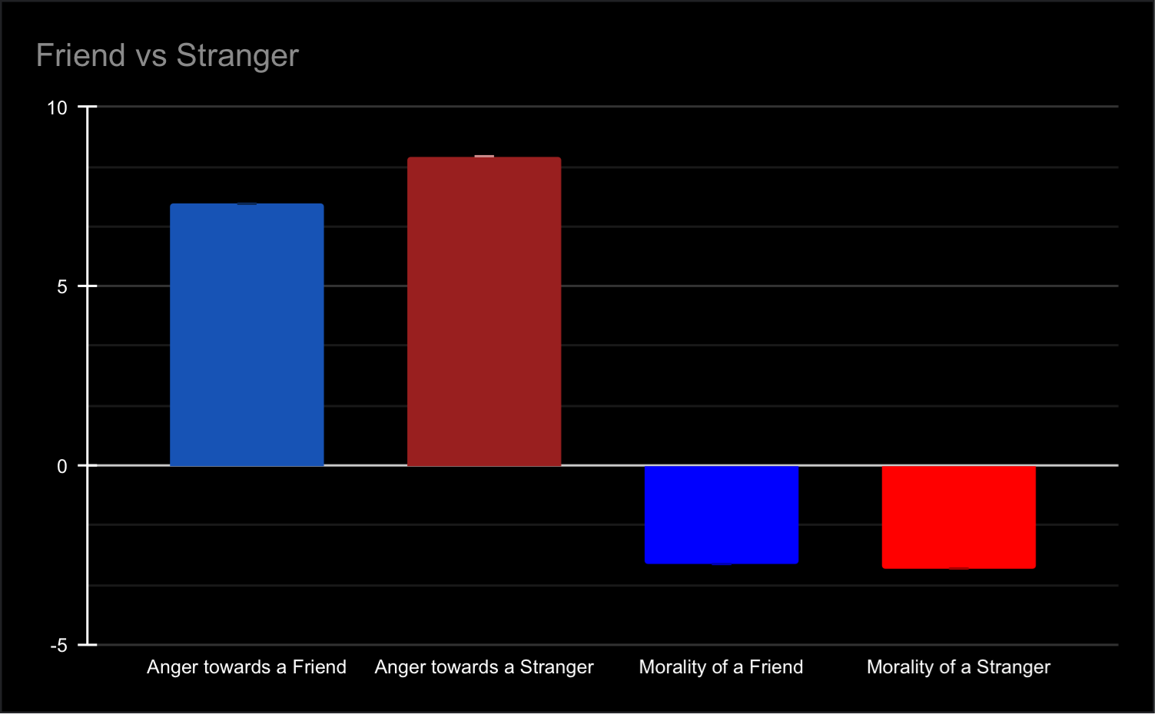
Figure1:The anger and morality level of each condition
As in figure1,it turns out that being unfairly treated by friends slightly triggers more
anger than by strangers.

Instructor comment: Descriptive results = what the results look like before any statistical analysis has been conducted (e.g., means and standard deviations). This refers to the descriptive statistics of the experiment and can be calculated using softwares (e.g., Microsoft Excel, JMP) based on the data that you have collected. This does not require statistical analysis.
Important:
You must present the averages as a bar chart following APA guidelines. See the following link (see ‘Figures’ part near the bottom of the page) for an example of a bar chart according to APA guidelines:
  - APA Tables and Figures - Purdue OWL
Report averages per level of the independent variable (i.e., per condition) and NOT per individual or per measure/question.
Use two numbers after the decimal point.
Figures should be numbered and have titles. You should reference your figure in the text at least once. For example: “Figure 1 shows the response times in each condition.”
If you have numerical values displayed in the figure, you do not need to repeat them in the text. The results should either be only in the text or only in the figure.

Discussion
Instructor comment: No separate text is needed under the main heading "Discussion" - Simply start writing under the subheading "Main discussion".
Main discussion
The study aimed to examine how people react emotionally to unfair treatment by friends versus strangers. We initially hypothesized that unfair treatment by friends would trigger greater anger, as friends are expected to be more considerate. However, the results showed the opposite: participants reported stronger anger when unfairly treated by strangers.
This suggests that anger may reflect perceptions of threat or disrespect rather than just violated expectations. Strangers’ unfairness might feel more hostile or unjustified, while unfair acts from friends may be excused or rationalized. These findings refine our understanding of emotional responses in social contexts, showing that relational closeness does not always intensify anger.
Future research could test how attribution and trust influence these reactions.

Instructor comment: Explain your interpretation of the results and how these relate to your hypotheses. Focus on using logical arguments and critical thinking, no personal opinions. Start with what was the goal of the study, then talk about what the major findings were, and follow with a discussion of what these results mean. You can also discuss: How do these findings add to our knowledge in psychology? What alternative interpretations can be placed on the data? What research follows from the study to move the field forward?

Limitations
1.The results of this study are unlikely to be replicated if the same method is followed, because asking participants to rate a highly specific scenario on the basis of their own moral values and emotions gives way to subjective results.
2. 2-3 participants in the survey were already aware of the hypothesis of this study prior to taking the survey, which may have led to biased responses in the data.
3.The gender category is redundant.
Instructor comment: Limit yourselves to no more than 2-3 limitations and do not be overly critical. Are there any limitations? If you think that there are, then be specific. It is not enough to say “The result might have been different with a different sample” – you must be able to specify logically how and why this is a specific limitation for your study and how the results would be different with a different design, sample, or approach, and what that would mean.
Conclusion
Instructor comment: Explain in 1-3 sentences what the main take home message of your experiment and findings is.
References
Instructor comment: list all references cited

